 

**AI/ Machine Learning Internship Program**

**Assignment II**

**TEAM NAME: IDEA IGNITERS**

**Member 1:** Gopika K G

Email:[gopisanju2004@gmail.com](mailto:gopisanju2004@gmail.com)

**Member 2:** Ashilin B S

Email: [ashilin04@gmail.com](mailto:ashilin04@gmail.com)

**Member 3:** Dhamayandhi R

Email: [kavindhamayandhi@gmail.com](mailto:kavindhamayandhi@gmail.com)

**Assignment: Predicting Flight Ticket Prices**

**Problem Statement:**

An online travel agency wants to predict the price of flight tickets based on various factors such as departure date, distance, airline, and class of service. Your task is to develop a machine learning model that predicts the price of a flight ticket given these attributes.

**Dataset:**

The dataset contains 5,000 records and consists of the following features related to flight ticket booking:

**1. FlightID:** Unique identifier for each flight.

**2. Airline:** The airline operating the flight (e.g., Delta, United, Southwest).

**3. DepartureAirport:** The airport from which the flight departs.

**4. ArrivalAirport:** The airport at which the flight arrives.

**5. DepartureDate:** The date of departure.

**6. Distance:** The distance between the departure and arrival airports (in miles).

**7. FlightDuration:** The duration of the flight (in hours).

**8. Class:** The class of service (e.g., Economy, Business, First).

**9. NumberOfStops:** The number of stops during the flight (e.g., Non-stop, 1 stop, 2+ stops).

**10. DaysUntilDeparture:** The number of days between booking and departure.

**11. DayOfWeek:** The day of the week the flight departs (e.g., Monday, Tuesday).

**12. TicketPrice:** The target variable representing the price of the flight ticket (in USD).

**Tasks:**

1. **Data Exploration and Preprocessing:**

The initial step involved loading the dataset and exploring its structure to understand the data. Using pandas, we performed the following:

* **Dataset Overview**: After loading the dataset using pd.read_csv, I examined its structure using functions like .info() and .describe(). This provided information on data types, missing values, and basic statistics (e.g., mean, max, min) of each feature.
* **Handling Missing Values and Outliers**: The dataset was checked for missing values and outliers using df.isnull().sum() and by plotting graphs. No missing values and outliers were present, so no further imputation steps were required.

Data columns (total 12 columns):

# Column Non-Null Count Dtype

--- ------ -------------- -----

0 FlightID 5000 non-null int64

1 Airline 5000 non-null object

2 DepartureAirport 5000 non-null object

3 ArrivalAirport 5000 non-null object

4 DepartureDate 5000 non-null object

5 Distance 5000 non-null int64

6 FlightDuration 5000 non-null float64

7 Class 5000 non-null object

8 NumberOfStops 5000 non-null int64

9 DaysUntilDeparture 5000 non-null int64

10 DayOfWeek 5000 non-null object

11 TicketPrice 5000 non-null float64

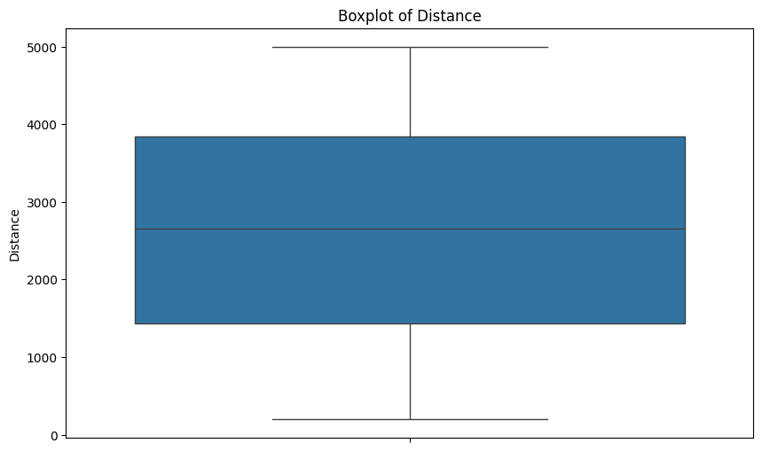

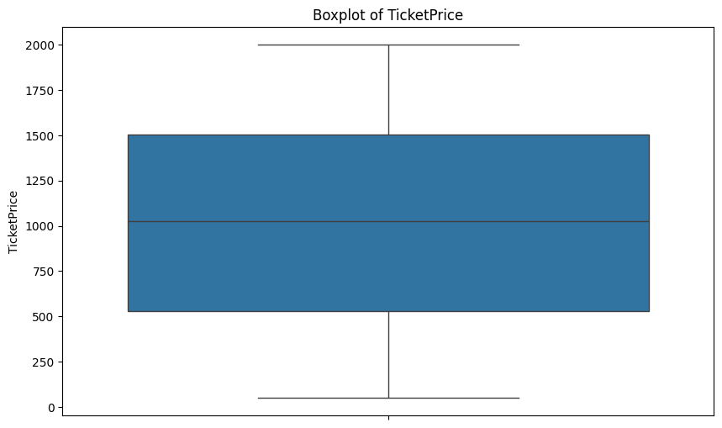

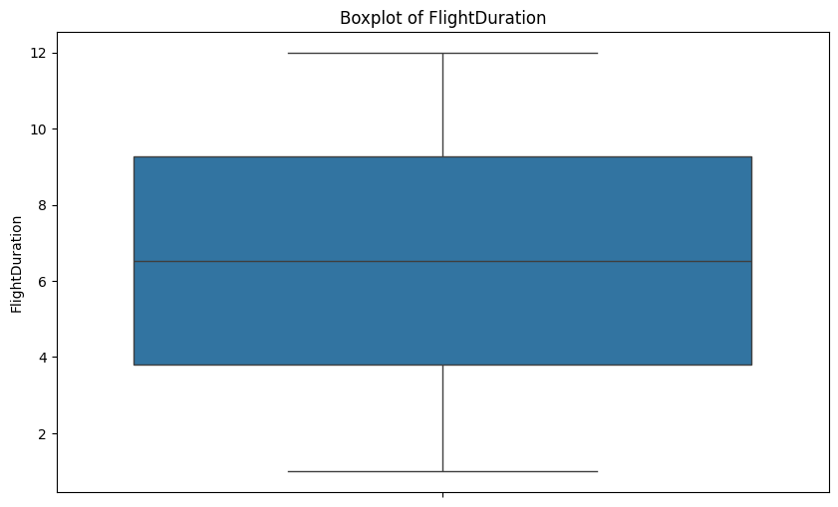

* **One-Hot Encoding**: The dataset contained categorical features such as Airline, DepartureAirport, ArrivalAirport, Class, and DayOfWeek. These features were converted into numerical format using One-Hot Encoding (pd.get_dummies), allowing the model to interpret categorical data appropriately.

1. **Feature Engineering:**

Feature engineering was performed to enrich the dataset and prepare it for modeling.

* **Scaling**: Continuous variables were scaled using MinMaxScaler from sklearn.preprocessing to bring all features into the same range. This prevents features with larger ranges from dominating the model.
* **New Features**: Several new features were engineered.
* **Price per Mile**: Calculated by dividing TicketPrice by Distance to provide insight into pricing relative to flight distance.
* **IsNonStop**: A binary feature indicating whether the flight had no stops (1) or multiple stops (0).
* **Duration per Mile**: Calculated by dividing FlightDuration by Distance, providing an indicator of the speed of the flight.
* **Flight Speed**: Calculated as Distance divided by FlightDuration, giving an estimate of the average flight speed.
* **Polynomial and Interaction Features**: To capture potential nonlinear relationships, new polynomial and interaction features were added:
* DistanceSquared and DaysUntilDepartureSquared to model quadratic effects
* Distance_DaysInteraction as an interaction between Distance and DaysUntilDeparture.
* **Dimensionality Reduction**: Although not used in this case, Principal Component Analysis (PCA) or other dimensionality reduction techniques could be applied if feature space becomes too large.

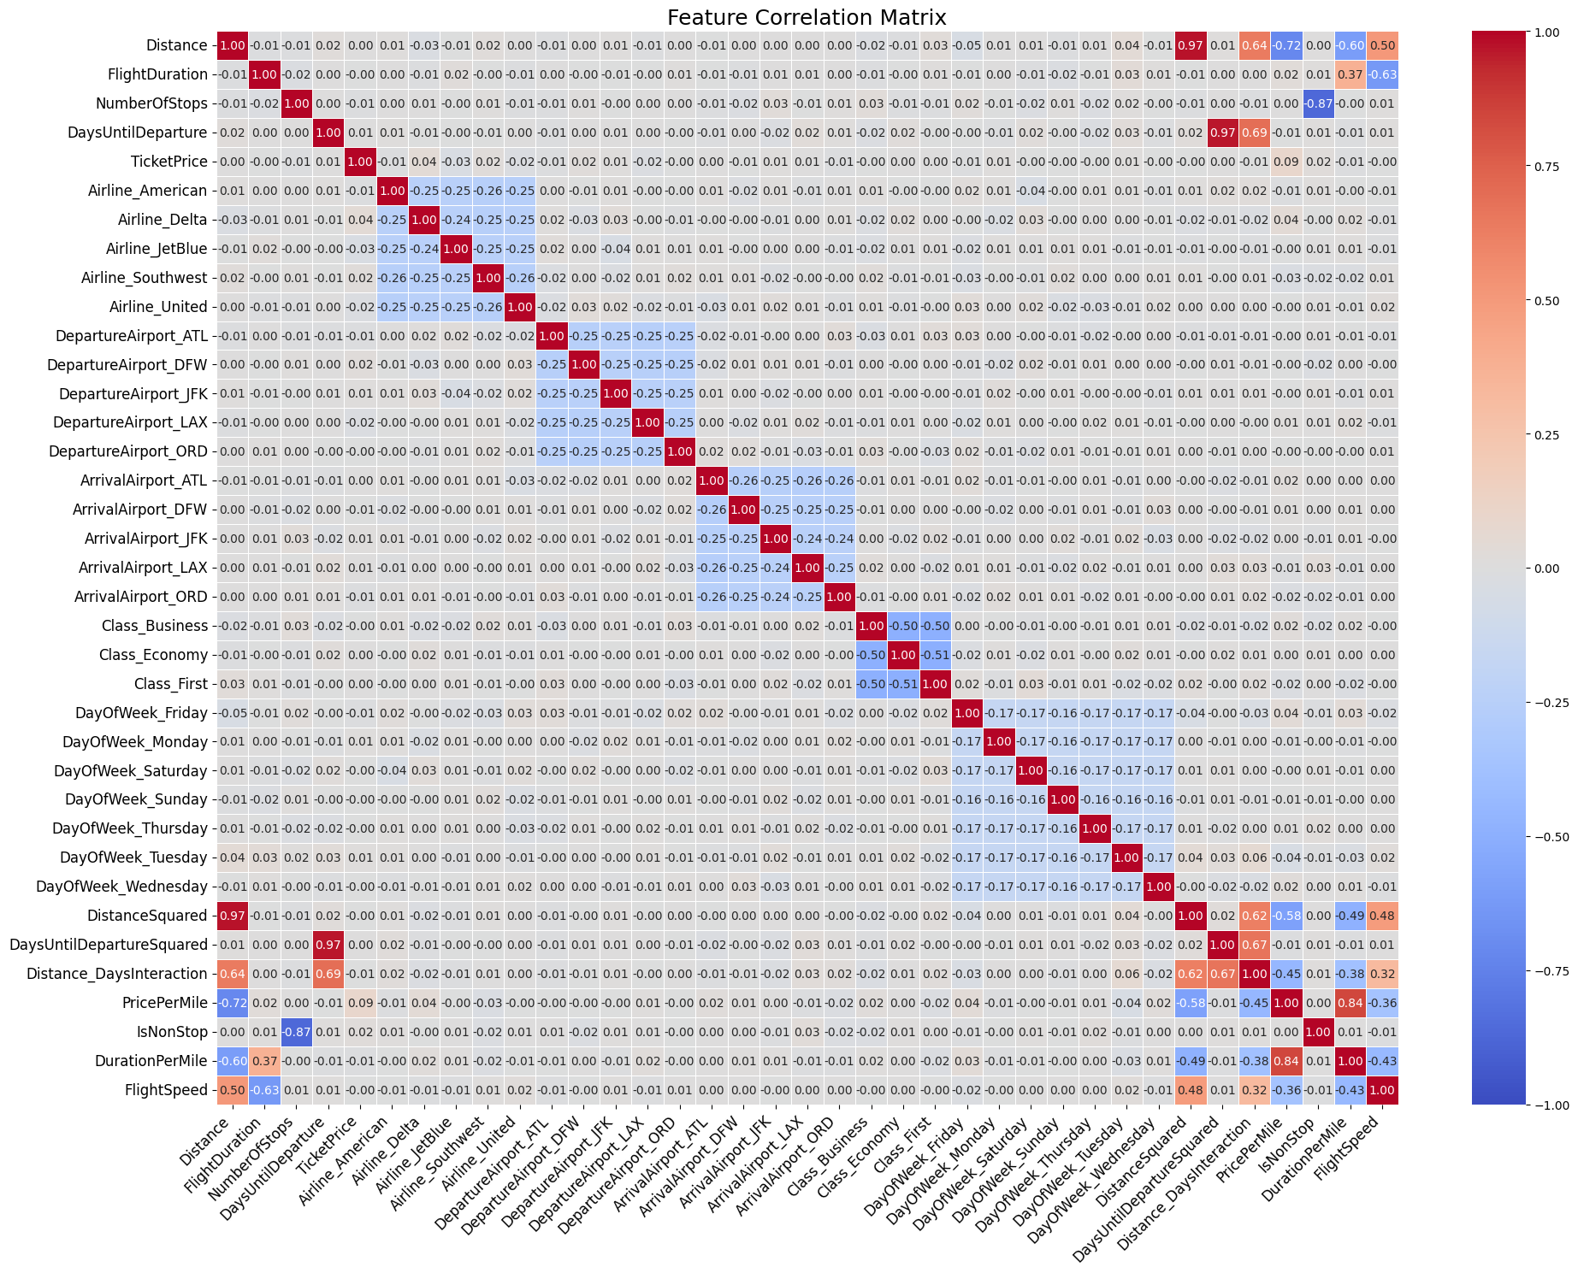

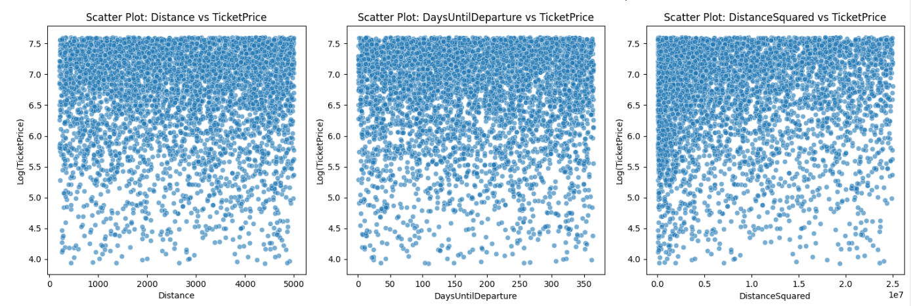

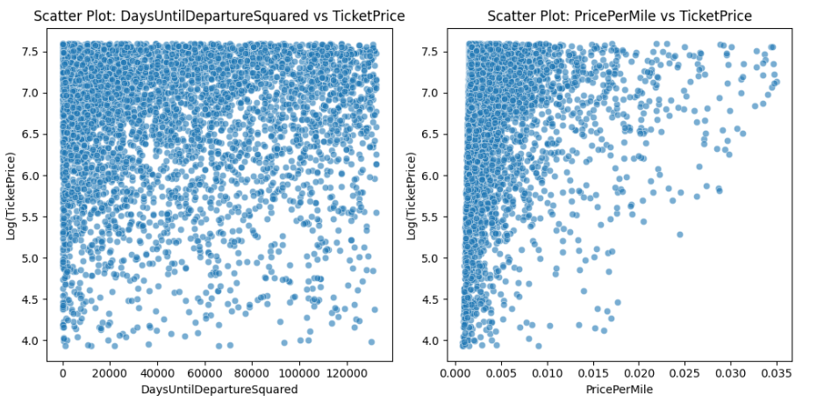

1. **Model Building:**

The next step was to build and train various models to predict ticket prices.

* **Train-Test Split**: The dataset was split into training and test sets using an 80-20 ratio, ensuring the model is tested on unseen data.
* **Model Selection**: We initially trained several models, including Linear Regression, XGBoost, and Random Forest. The Random Forest model was chosen for its robust performance in capturing complex relationships within the data.
* **Hyperparameter Tuning**: To optimize model performance, Grid Search was used to tune the hyperparameters of the Random Forest model. The hyperparameters tuned included n_estimators, max_depth, min_samples_split, and max_features. The best parameters were selected based on the lowest Mean Squared Error (MSE) during cross-validation.

1. **Model Evaluation:**

The model was evaluated using several metrics to assess its performance:

* **Mean Squared Error (MSE)**, **Root Mean Squared Error (RMSE)**, and **Mean Absolute Error (MAE)** were calculated on the test set to quantify the error between predicted and actual ticket prices.
* **R-squared**: The R-squared value was computed to understand how well the model explains the variance in the target variable (TicketPrice).
* **Cross-Validation**: A cross-validation strategy was applied to the Random Forest model using a 5-fold split, providing a more reliable estimate of model performance.
* **Feature Importance**: The importance of individual features was analyzed using the feature_importances_ attribute of the Random Forest model. A bar plot was generated to visualize the top 10 features, helping to understand which factors contribute most to the prediction.

**Best Cross-Validated MSE:** 0.0015200034434160942

**Mean Squared Error (MSE):** 0.0011282136934434354

**Root Mean Squared Error (RMSE):** 0.03358889241168032

**Mean Absolute Error (MAE):** 0.019266355128963807

**R-squared Score: 0.9772910119981815**

**Cross-validated MSE:** 0.0015200034434160942

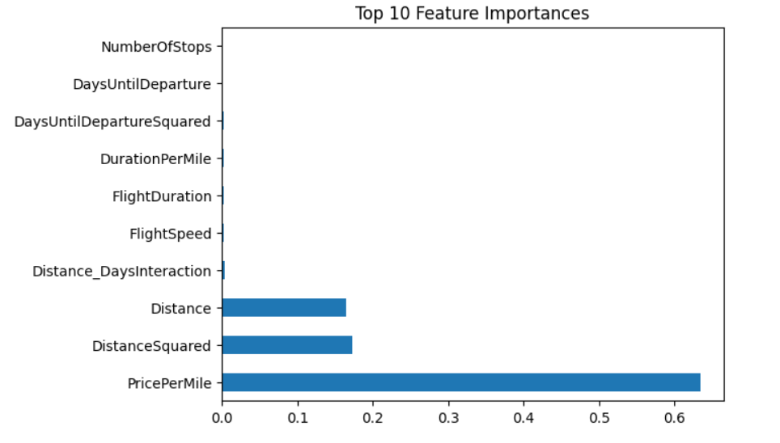

1. **Comparison of various models:**

Comparison table based on the results from the Random Forest, Linear Regression, and XGBRegressor models:

|  |  |  |  |
| --- | --- | --- | --- |
| Metric | Random Forest | Linear Regression | XGBRegressor |
| Best Cross-Validated MSE | 0.00152 | N/A | 0.00320 |
| MSE (Mean Squared Error) | 0.00112 | 0.79021 | 0.00297 |
| RMSE (Root Mean Squared Error) | 0.03351 | 0.88894 | 0.05449 |
| MAE (Mean Absolute Error) | 0.01919 | 0.70268 | 0.03821 |
| R-squared | 0.97739 | 0.21822 | 0.94023 |
| Cross-validated MSE | 0.00152 | N/A | 0.00320 |

* **Summary:**
* **Random Forest:**
* **Best Performance:** The Random Forest model outperformed both Linear Regression and XGBRegressor in terms of all evaluation metrics. It achieved the lowest MSE (0.00112), RMSE (0.03351), and MAE (0.01919), with an R-squared score of 0.97739, indicating that it explained approximately 98% of the variance in the data. This suggests that Random Forest captured the underlying patterns in the dataset most effectively.
* **Cross-validated MSE:** The cross-validation results were consistent with the test set, confirming its robustness.
* **XGBRegressor:**
* **Strong Performance:** XGBRegressor also performed well, achieving a relatively low MSE (0.00297) and high R-squared score (0.94023). It was slightly less accurate than Random Forest but still provided strong predictive capability. The cross-validated MSE of 0.00320 was also higher than that of Random Forest, indicating slight overfitting or less generalization capability.
* **Balanced Option:** XGBRegressor is a good balance between accuracy and complexity, and it could be preferable if computational efficiency is a priority.
* **Linear Regression:**
* **Poor Performance**: Linear Regression underperformed compared to the other models, with a much higher MSE (0.79021), RMSE (0.88894), and MAE (0.70268). Its R-squared score was only0.21822, indicating that it explained only 21% of the variance in the data. This suggests that Linear Regression struggled to capture the non-linear relationships in the dataset.
* **Baseline Model:** Linear Regression served as a baseline model, but it is not suitable for this problem due to its inability to model complex relationships.

1. **Insights and Recommendations:**

Based on the model analysis, the following insights were derived:

* **Distance** and **DaysUntilDeparture** were key factors influencing ticket prices, as evidenced by their high feature importance scores. Flights booked closer to the departure date and longer-distance flights tend to be priced higher.
* **Flight Class** and **Airline** also had significant influence, suggesting that premium classes and certain airlines charge higher prices.
* **Recommendations for the Travel Agency**:
* **Dynamic Pricing**: Implement dynamic pricing strategies that account for both distance and days until departure. Offering discounts for early bookings or shorter flights could attract more customers.
* **Class-based Promotions**: Promote lower-cost seating classes to increase occupancy in flights with available seats.
* **Flight Speed Insights**: Utilize flight speed insights to highlight faster flight options to customers, potentially enhancing customer satisfaction by reducing travel time.

**Screenshots of working of Flight Ticket Price predictor:**





